SCHOOL OF TECHNOLOGY | 

DATABASE MANAGEMENT SYSTEMS
PROJECT-BASED LEARNING (PBL) REPORT
Small Database Application Development using Java / Python

PROJECT TITLE
BLOOD BANK DONATION AND ISSUE MANAGEMENT SYSTEM

Program | B.Tech Computer Science & Engineering
Section | Rhinos AI/ML
Faculty | Prof. Sahithi
Date of Submission
Academic Year | 2026 – 27

Submitted by
Roll Number | Student Name | Mobile | Email ID
25WU0102067 | Andrew Devasani | 703806767 | andrewdevasani@gmail.com

ACKNOWLEDGEMENT

I express my sincere gratitude to Woxsen University, School of Technology, for providing me with the opportunity to undertake this Project-Based Learning (PBL) activity as part of the Database Management Systems (DBMS) course.
I thank my course faculty, Prof. Sahiti, for the guidance, suggestions, and support throughout the design and development of this project. The guidance helped me understand the practical application of database concepts such as ER modelling, relational schema design, normalization, SQL, constraints, queries, and database application development.
This PBL activity has strengthened my understanding of DBMS concepts and provided valuable experience in applying them to a real-world problem.

UNDERTAKING

I hereby declare that the project entitled “Blood Bank Donation and Issue Management System”, submitted as part of the Project-Based Learning activity for the Database Management Systems (DBMS) course, is my individual work carried out under the guidance of the course faculty.
I undertake that the project report, database design, SQL scripts, application source code, results, and supporting materials submitted by me have been prepared for academic purposes. Wherever information, ideas, tools, datasets, or other resources have been referred to, appropriate acknowledgement has been provided.
I further undertake that I am responsible for the correctness and authenticity of the work submitted and that I have followed the academic and project guidelines prescribed by the University.

 |  |  |  | Signature
Date | : |  | Name: | Andrew Devasani
Place | : | Hyderabad | Roll Number: | 25WU0102067
 |  |  | Program: | B.Tech CSE

TABLE OF CONTENTS

Contents | Page No.
Abstract | 7
LIST OF TABLES | 5
LIST OF FIGURES | 5
LIST OF ACRONYMS | 6
1. PROBLEM STATEMENT, SOLUTION STRATEGY AND ER DIAGRAM | 8
1.1 Problem Statement | 8
1.2 Objectives | 8
1.3 Scope and Assumptions | 9
1.4 Proposed Solution Strategy | 9
1.5 Functional Requirements | 10
1.6 Entity-Relationship Diagram (ERD) | 10
1.7 Entity and Relationship Summary | 11
2. LOGICAL DATABASE DESIGN | 13
2.1 Relational Schema | 13
2.2 Keys and Integrity Constraints | 13
2.3 Functional Dependencies | 14
2.4 Normalization up to Third Normal Form (3NF) | 15
2.5 Data Dictionary | 15
2.6 Implementation of Logical Design: DDL and Sample Data | 17
3. APPLICATION DEVELOPMENT USING LOGICAL DATABASE DESIGN | 20
3.1 Application Overview | 20
3.2 Development Environment and Database Connectivity | 20
3.3 Application Modules and Database Mapping | 21
3.4 CRUD Operations | 21
3.5 Business Rules, Validation and Error Handling | 22
3.6 Reports and Database Operations | 23
3.7 Application Screens | 23
3.8 Testing and Results | 28
4. CONCLUSION | 30
4.1 Limitations and Future Enhancements | 30
5. REFERENCES | 31
6. APPENDICES | 32

LIST OF TABLES

Table No. | Table Title | Page No.
Table 1 | Scope and Assumptions | 9
Table 2 | Proposed Solution Strategy | 9
Table 3 | Functional Requirements | 10
Table 4 | Entity and Relationship Summary | 11
Table 5 | Relational Schema | 13
Table 6 | Keys and Integrity Constraints | 14
Table 7 | Normalization Status up to 3NF | 15
Table 8 | Data Dictionary | 16
Table 9 | Database Implementation Environment | 17
Table 10 | Application Development Environment | 20
Table 11 | Application Module-to-Database Mapping | 21
Table 12 | CRUD Operations | 21
Table 13 | Business Rules, Validation and Error Handling | 22
Table 14 | Reports and Database Operations | 23
Table 15 | Test Cases | 28

LIST OF FIGURES

Figure No. | Figure Title | Page No.
Figure 1 | Entity-Relationship Diagram of the Proposed System | 11
Figure 2 | Login Screen with Role-Based Access | 24
Figure 3 | Dashboard with Live KPI Cards, Inventory Grid and Low-Stock Alert | 24
Figure 4 | Donor Registration and Search | 25
Figure 5 | Donation Recording and Inventory Increment | 26
Figure 6 | Blood Request Approval and Atomic Blood Issue | 27
Figure 7 | Reports Page with Donation Distribution Chart | 28

LIST OF ACRONYMS

Acronym | Expansion
1NF | First Normal Form
2NF | Second Normal Form
3NF | Third Normal Form
ACID | Atomicity, Consistency, Isolation, Durability
BCNF | Boyce-Codd Normal Form
CRUD | Create, Read, Update, Delete
CSRF | Cross-Site Request Forgery
CSS | Cascading Style Sheets
DBMS | Database Management System
DDL | Data Definition Language
DML | Data Manipulation Language
ER | Entity-Relationship
ERD | Entity-Relationship Diagram
FD | Functional Dependency
FK | Foreign Key
HTML | HyperText Markup Language
IDE | Integrated Development Environment
IEEE | Institute of Electrical and Electronics Engineers
KPI | Key Performance Indicator
PBL | Project-Based Learning
PK | Primary Key
RDBMS | Relational Database Management System
SQL | Structured Query Language
UI | User Interface

ABSTRACT

Blood banks must keep accurate records of donors, donated units, available stock in each of the eight ABO/Rh groups and hospital requests, because an error in any of them can delay a patient's treatment. Manual registers and spreadsheets cannot guarantee that stock figures stay consistent when several staff members work at once. The objective of this project is to design and implement a relational database application that manages blood donation and issue while keeping inventory consistent. An entity-relationship model was converted into six normalized MySQL tables with primary keys, foreign keys, UNIQUE and CHECK constraints, and a Python Flask web application was developed on top of it using parameterised queries and role-based login for administrators and staff. The system supports donor registration and search, donation recording and acceptance, live inventory with low-stock alerts, hospital requests, and blood issue. Inventory updates and blood issue run as transactions with row-level locking, so stock never becomes negative and a request cannot be issued twice. Dashboard and report pages use aggregate SQL queries, and eleven automated tests confirm the main workflows and validation rules. The prototype shows how sound database design, constraints and transactions combine to give a reliable blood bank record system.

KEYWORDS
Keywords: Relational Database, ER Diagram, Normalization, MySQL Transactions, Flask, Blood Bank Management

CHAPTER 1

PROBLEM STATEMENT, SOLUTION STRATEGY AND ER DIAGRAM

1.1 Problem Statement
A blood bank has to reconcile three streams of information all the time: who donates, how many usable units are on the shelf in each of the eight ABO/Rh groups, and which hospital requests have been served. When these are tracked in paper registers or loosely linked spreadsheets, the figures drift away from reality. A donation is logged but never added to stock, a unit is dispatched but not deducted, two staff members promise the last unit of a rare group to different patients, or the same request is fulfilled twice. These mistakes are costly because blood is perishable, groups such as O- and AB- are scarce, and a wrong stock figure can delay treatment [1].
The people affected are donors (whose history must be preserved and whose eligibility must be checked), blood bank staff and administrators (who need fast search, correct counts and an audit trail), and the hospitals and patients who depend on timely and accurate supply. The manual process offers no automatic validation of donor age, no protection against negative or duplicated issue, and no quick way to produce summary reports. A database application that stores the data in related tables, enforces rules through constraints, and performs stock changes as transactions is therefore needed.

1.2 Objectives
- Design a normalized relational database of six tables (users, donors, donations, inventory, blood requests and blood issues) with primary keys, foreign keys, UNIQUE and CHECK constraints.
- Develop a Python Flask web application with role-based login for Admin and Staff that performs create, read, update and controlled-removal operations using parameterised SQL.
- Implement transactional stock management so that accepted donations increase and blood issues decrease inventory atomically, never below zero and never twice for the same request.
- Generate live dashboard statistics and reports through aggregate SQL queries, and validate the system with eleven automated positive and negative test cases.

1.3 Scope and Assumptions
Table 1 lists what the project covers, what it deliberately leaves out, and the assumptions made while designing it.
Table 1. Scope and Assumptions
Item | Description
In Scope | Donor registry (register, search, edit, deactivate); donation recording with lab acceptance or rejection; live inventory for the eight blood groups with low-stock alert (threshold 5 units); hospital blood requests with approval or rejection; atomic blood issue; dashboard and reports; Admin-only staff account management; login, role-based access and CSRF protection.
Out of Scope / Exclusions | Component-wise inventory (plasma, platelets); expiry and shelf-life tracking; individual unit or bag traceability; clinical screening and cross-matching; multiple branches; SMS or email notifications; clinical use of any kind, since the system is an educational prototype.
Assumptions | One blood bank operates the system; every donated unit is a unit of whole blood; the donor's blood group is verified at registration; a request is for one blood group and is issued in full or not at all; staff users are trusted; MySQL runs on the local machine.

1.4 Proposed Solution Strategy
The proposed solution is a three-layer web application. A browser interface built with HTML5, CSS3 and JavaScript talks to a Flask backend [2], which reads and writes a MySQL 8 database [3] through parameterised queries. All business rules that must never be broken, such as non-negative stock and one issue per request, are enforced twice: in the application code for friendly error messages and in the database through constraints and transactions. Table 2 summarises the users, modules, workflow, rules and outputs of the solution.
Table 2. Proposed Solution Strategy
Solution Element | Project-Specific Description
Primary Users / Roles | Admin: full access including staff account management. Staff: donor registration, donations, requests, blood issue and viewing inventory and reports.
Major Application Modules | Login and role access; Dashboard; Donor Management; Blood Donations; Blood Inventory; Blood Requests; Blood Issues; Reports; User Management (Admin only).
Proposed Workflow | Register donor → record donation (Pending, Accepted or Rejected) → accepted units are added to inventory → hospital request is created as Pending → request is Approved or Rejected → an Approved request is issued, which deducts stock, writes an issue record and marks the request Fulfilled.
Important Business Rules | Donor age must be 18 to 65; units must be positive; only active donors can donate; an accepted donation is counted in stock once; only Approved requests can be issued; one issue per request; stock can never go below zero; a Fulfilled request cannot be changed; donors are deactivated, not deleted, so history is preserved.
Expected Reports / Outputs | Dashboard KPI cards; eight-group inventory grid with low-stock alert; donations by blood group (table and bar chart); monthly donation summary; request and issue performance; recent donations and requests.

1.5 Functional Requirements
The functional requirements derived from the problem statement are listed in Table 3.
Table 3. Functional Requirements
Req. ID | Functional Requirement | Remarks / Priority
FR-01 | Authenticate users with username and password; store only password hashes. | High
FR-02 | Restrict features by role; user management is available to Admin only. | High
FR-03 | Register, search (name, phone, ID), filter by blood group, edit and deactivate or reactivate donors. | High
FR-04 | Record donations for active donors; the blood group is taken from the donor record. | High
FR-05 | Accept or reject pending donations; accepted units are added to inventory exactly once. | High
FR-06 | Maintain live inventory for the eight blood groups and raise a low-stock alert. | High
FR-07 | Create hospital blood requests with patient, hospital, blood group and units. | High
FR-08 | Approve or reject requests while showing units demanded against units available. | Medium
FR-09 | Issue blood only for Approved requests with sufficient stock, as one atomic transaction. | High
FR-10 | Prevent a request from being issued more than once. | High
FR-11 | Show dashboard statistics and reports with aggregate queries and a chart. | Medium
FR-12 | Allow Admin to create, activate and deactivate staff accounts. | Medium

1.6 Entity-Relationship Diagram (ERD)
The Entity-Relationship model [4] of the system is shown in Figure 1. It has six entities. A donor makes many donations, and every donation is recorded by exactly one user. Users also create blood requests and authorize blood issues. A request is fulfilled by at most one issue. The INVENTORY entity holds one row per blood group; it is connected to donations and issues by the shared blood_group value rather than by a foreign key, and the application keeps it consistent inside transactions.
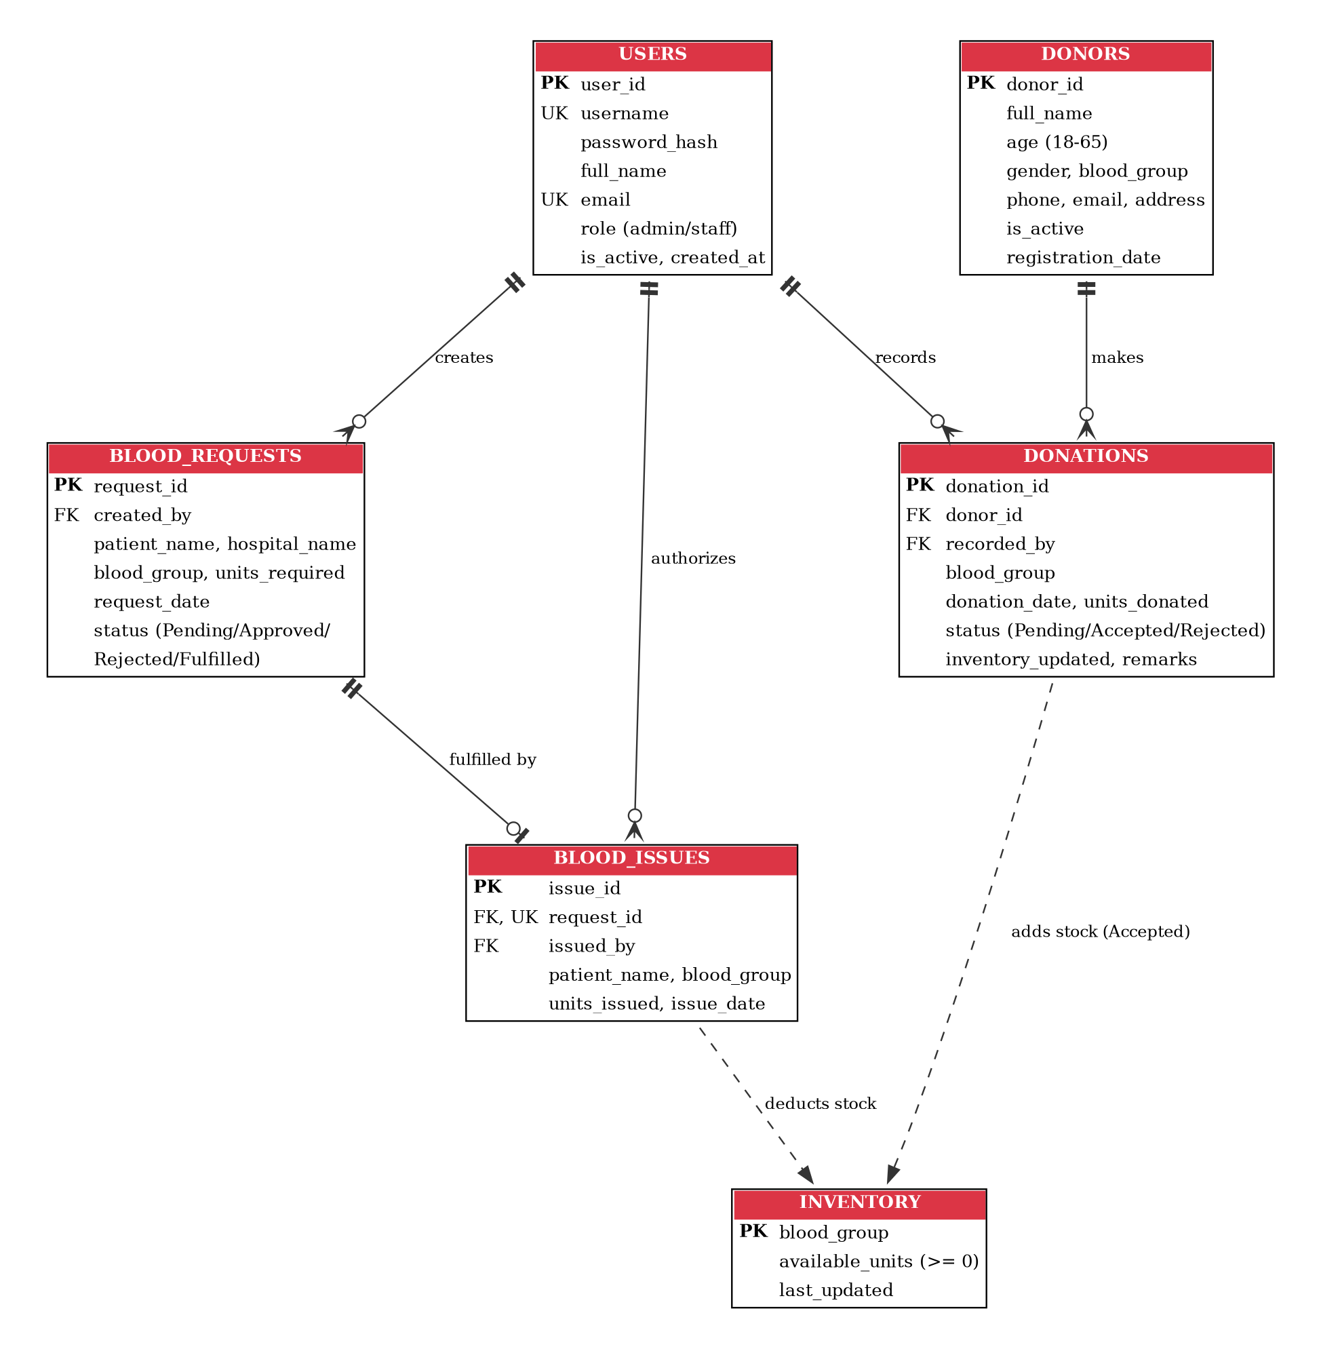
Figure 1. Entity-Relationship Diagram of the Proposed System

1.7 Entity and Relationship Summary
Table 4 summarises each entity and relationship together with its cardinality and the rule it carries.
Table 4. Entity and Relationship Summary
Entity / Relationship | Major Attributes / Cardinality | Purpose / Rule
USERS | user_id (PK), username, email, role | System operators; the role decides what each user may do.
DONORS | donor_id (PK), full_name, age, blood_group, phone | Donor registry; age 18–65; deactivated rather than deleted.
DONATIONS | donation_id (PK), donor_id (FK), recorded_by (FK), units_donated, status | One donation event; accepted units are counted in stock once.
INVENTORY | blood_group (PK), available_units | Exactly eight rows; available_units can never be negative.
BLOOD_REQUESTS | request_id (PK), created_by (FK), blood_group, units_required, status | Hospital requisition that moves from Pending to Approved or Rejected and finally Fulfilled.
BLOOD_ISSUES | issue_id (PK), request_id (FK, UNIQUE), issued_by (FK), units_issued | Formal dispatch record; one per request.
DONORS makes DONATIONS | 1 : N (a donor may have zero or many donations) | Each donation belongs to exactly one donor.
USERS records DONATIONS | 1 : N | Each donation is recorded by exactly one user.
USERS creates BLOOD_REQUESTS | 1 : N | Each request stores the user who created it.
BLOOD_REQUESTS fulfilled by BLOOD_ISSUES | 1 : 0..1 | UNIQUE(request_id) allows at most one issue per request.
USERS authorizes BLOOD_ISSUES | 1 : N | Each issue stores the authorizing user.
DONATIONS / BLOOD_ISSUES update INVENTORY | N : 1 through blood_group (logical) | Accepted donation adds units; issue deducts units; both inside transactions.

CHAPTER 2

LOGICAL DATABASE DESIGN

2.1 Relational Schema
The ER model was mapped to the relational model [5] by turning every entity into a table, every one-to-many relationship into a foreign key on the many side, and the one-to-one relationship between requests and issues into a foreign key with a UNIQUE constraint. The six relations are listed in Table 5, and their schema is written below it with primary keys underlined by (PK) and foreign keys marked (FK).
Table 5. Relational Schema
S.No. | Table Name | Purpose
1 | users | System authentication and role-based access (Admin or Staff).
2 | donors | Registry of prospective and active blood donors.
3 | inventory | Live available units for each of the eight blood groups.
4 | donations | Log of donations made by registered donors and their lab status.
5 | blood_requests | Blood requests raised for patients by hospitals.
6 | blood_issues | Record of blood units formally issued against approved requests.

users(user_id PK, username, password_hash, full_name, email,
role, is_active, created_at)
donors(donor_id PK, full_name, age, gender, blood_group, phone,
email, address, is_active, registration_date, created_at)
inventory(blood_group PK, available_units, last_updated)
donations(donation_id PK, donor_id FK, blood_group, donation_date,
units_donated, status, recorded_by FK, inventory_updated,
remarks, created_at)
blood_requests(request_id PK, patient_name, hospital_name,
blood_group, units_required, request_date, status,
created_by FK, created_at)
blood_issues(issue_id PK, request_id FK UNIQUE, patient_name,
blood_group, units_issued, issue_date, issued_by FK,
created_at)

2.2 Keys and Integrity Constraints
Table 6 lists the keys and integrity constraints declared in schema.sql. All foreign keys use ON UPDATE CASCADE and ON DELETE RESTRICT, so a parent row that still has children can never be deleted. Five secondary indexes support the most frequent searches: idx_donors_search (full_name, blood_group, is_active), idx_donations_status, idx_donations_donor, idx_requests_status and idx_issues_date.
Table 6. Keys and Integrity Constraints
Table Name | Key / Constraint | Attribute(s) | Business Rule Enforced
users | Primary Key | user_id | Each user is uniquely identified.
users | Unique | username, email | No two accounts share a login name or email.
users | Not Null / Default | password_hash, role = 'staff', is_active = TRUE | Every account has a hash and a role; new accounts default to active staff.
donors | Primary Key | donor_id | Each donor is uniquely identified.
donors | Check | chk_donor_age: age >= 18 AND age <= 65 | Only eligible-age donors can be registered.
donors | Not Null / Default | full_name, age, gender, blood_group, phone; is_active = TRUE; registration_date = CURRENT_DATE | Mandatory donor details; blood group limited to eight ENUM values.
inventory | Primary Key | blood_group | Exactly one stock row per blood group.
inventory | Check / Default | chk_inventory_non_negative: available_units >= 0; default 0 | Stock can never become negative.
donations | Primary Key | donation_id | Each donation is uniquely identified.
donations | Foreign Key | donor_id → donors; recorded_by → users | A donation needs a valid donor and a valid recording user; RESTRICT keeps history.
donations | Check / Default | units_donated > 0; status = 'Pending'; inventory_updated = FALSE | Positive units; new donations start Pending and uncounted.
blood_requests | Primary Key | request_id | Each request is uniquely identified.
blood_requests | Foreign Key | created_by → users | Every request is traceable to its creator.
blood_requests | Check / Default | units_required > 0; status = 'Pending' | Positive demand; status limited to Pending, Approved, Rejected, Fulfilled.
blood_issues | Primary Key | issue_id | Each issue is uniquely identified.
blood_issues | Unique | request_id | A request can be issued at most once.
blood_issues | Foreign Key | request_id → blood_requests; issued_by → users | An issue needs a real request and an authorizing user.
blood_issues | Check | units_issued > 0 | Positive issued units.

2.3 Functional Dependencies
The important functional dependencies (FDs) of the design are listed below. Every non-key attribute depends only on the key of its own table.
- users: user_id → username, password_hash, full_name, email, role, is_active, created_at. The candidate keys username and email also determine all other attributes.
- donors: donor_id → full_name, age, gender, blood_group, phone, email, address, is_active, registration_date, created_at.
- inventory: blood_group → available_units, last_updated.
- donations: donation_id → donor_id, blood_group, donation_date, units_donated, status, recorded_by, inventory_updated, remarks, created_at. Across relations, donor_id → blood_group holds in donors.
- blood_requests: request_id → patient_name, hospital_name, blood_group, units_required, request_date, status, created_by, created_at.
- blood_issues: issue_id → request_id, patient_name, blood_group, units_issued, issue_date, issued_by, created_at; request_id (UNIQUE) → issue_id and all other attributes.

2.4 Normalization up to Third Normal Form (3NF)
Every attribute in the schema holds a single atomic value, and every table has a primary key, so all six relations are in First Normal Form (1NF) [1]. Each primary key is a single column, so partial dependencies cannot exist and the relations are in Second Normal Form (2NF). For Third Normal Form (3NF), no non-key attribute may depend on another non-key attribute. Table 7 records the result relation by relation.
Two relations deserve an honest remark. In blood_issues, patient_name and blood_group are copied from the request at issue time to keep an audit snapshot. They are determined by request_id, which is a candidate key because of the UNIQUE constraint, so 3NF and Boyce-Codd Normal Form (BCNF) still hold. In donations, blood_group duplicates the donor's blood group (donor_id → blood_group), which is a transitive dependency. It was kept deliberately: the application always copies the value from the donor record at insert time, and the inventory update then needs no join. A strictly 3NF design would drop this column and join to donors when needed.
Table 7. Normalization Status up to 3NF
Relation Name | 1NF | 2NF | 3NF | BCNF | Remarks / Decomposition
users | Yes | Yes | Yes | Yes | All determinants (user_id, username, email) are candidate keys.
donors | Yes | Yes | Yes | Yes | No dependency other than on donor_id.
inventory | Yes | Yes | Yes | Yes | Only the stock level is stored per blood group.
donations | Yes | Yes | Exception | No | blood_group repeats donors.blood_group (controlled denormalization, see text).
blood_requests | Yes | Yes | Yes | Yes | Staff details are reached through created_by, not repeated.
blood_issues | Yes | Yes | Yes | Yes | Snapshot columns depend on candidate key request_id.

2.5 Data Dictionary
Table 8 gives the data dictionary for all six tables.
Table 8. Data Dictionary
Table | Attribute | Data Type | Key / Constraint | Description
users | user_id | INT | PK, AUTO_INCREMENT | Unique identifier of a system user
 | username | VARCHAR(50) | NOT NULL, UNIQUE | Login name
 | password_hash | VARCHAR(255) | NOT NULL | Werkzeug scrypt hash of the password
 | full_name | VARCHAR(100) | NOT NULL | Name of the staff member
 | email | VARCHAR(100) | NOT NULL, UNIQUE | Official email address
 | role | ENUM('admin','staff') | NOT NULL, DEFAULT 'staff' | Access role
 | is_active | BOOLEAN | NOT NULL, DEFAULT TRUE | Whether the account may log in
 | created_at | TIMESTAMP | DEFAULT CURRENT_TIMESTAMP | Account creation time
donors | donor_id | INT | PK, AUTO_INCREMENT | Unique identifier of a donor
 | full_name | VARCHAR(100) | NOT NULL | Donor name
 | age | INT | NOT NULL, CHECK 18–65 | Donor age in years
 | gender | ENUM('Male','Female','Other') | NOT NULL | Donor gender
 | blood_group | ENUM (8 groups) | NOT NULL | ABO/Rh group of the donor
 | phone | VARCHAR(20) | NOT NULL | Contact number
 | email | VARCHAR(100) | NULL | Optional contact email
 | address | VARCHAR(255) | NULL | Optional residential address
 | is_active | BOOLEAN | NOT NULL, DEFAULT TRUE | Soft-deactivation flag
 | registration_date | DATE | NOT NULL, DEFAULT CURRENT_DATE | Date of registration
 | created_at | TIMESTAMP | DEFAULT CURRENT_TIMESTAMP | Row creation time
inventory | blood_group | ENUM (8 groups) | PK | Blood group the stock belongs to
 | available_units | INT | NOT NULL, DEFAULT 0, CHECK >= 0 | Units currently in stock
 | last_updated | TIMESTAMP | ON UPDATE CURRENT_TIMESTAMP | Time of last stock change
donations | donation_id | INT | PK, AUTO_INCREMENT | Unique identifier of a donation
 | donor_id | INT | NOT NULL, FK → donors | Donor who gave blood
 | blood_group | ENUM (8 groups) | NOT NULL | Group copied from the donor record
 | donation_date | DATE | NOT NULL, DEFAULT CURRENT_DATE | Date blood was donated
 | units_donated | INT | NOT NULL, DEFAULT 1, CHECK > 0 | Units donated
 | status | ENUM('Pending','Accepted','Rejected') | NOT NULL, DEFAULT 'Pending' | Lab decision on the donation
 | recorded_by | INT | NOT NULL, FK → users | User who recorded the donation
 | inventory_updated | BOOLEAN | NOT NULL, DEFAULT FALSE | TRUE once the units were added to stock
 | remarks | VARCHAR(255) | NULL | Lab or screening notes
 | created_at | TIMESTAMP | DEFAULT CURRENT_TIMESTAMP | Row creation time
blood_requests | request_id | INT | PK, AUTO_INCREMENT | Unique identifier of a request
 | patient_name | VARCHAR(100) | NOT NULL | Patient who needs blood
 | hospital_name | VARCHAR(150) | NOT NULL | Requesting hospital
 | blood_group | ENUM (8 groups) | NOT NULL | Blood group required
 | units_required | INT | NOT NULL, CHECK > 0 | Units requested
 | request_date | DATE | NOT NULL, DEFAULT CURRENT_DATE | Date of the request
 | status | ENUM('Pending','Approved','Rejected','Fulfilled') | NOT NULL, DEFAULT 'Pending' | Current stage of the request
 | created_by | INT | NOT NULL, FK → users | User who created the request
 | created_at | TIMESTAMP | DEFAULT CURRENT_TIMESTAMP | Row creation time
blood_issues | issue_id | INT | PK, AUTO_INCREMENT | Unique identifier of an issue
 | request_id | INT | NOT NULL, UNIQUE, FK → blood_requests | Request being fulfilled
 | patient_name | VARCHAR(100) | NOT NULL | Patient name copied at issue time
 | blood_group | ENUM (8 groups) | NOT NULL | Blood group dispatched
 | units_issued | INT | NOT NULL, CHECK > 0 | Units dispatched
 | issue_date | DATE | NOT NULL, DEFAULT CURRENT_DATE | Date of dispatch
 | issued_by | INT | NOT NULL, FK → users | User who authorized the issue
 | created_at | TIMESTAMP | DEFAULT CURRENT_TIMESTAMP | Row creation time

2.6 Implementation of Logical Design: DDL and Sample Data
The design was implemented in MySQL, using the InnoDB engine so that foreign keys and transactions are supported. Table 9 gives the environment. Representative CREATE TABLE statements follow; the complete script is in Appendix A.
Table 9. Database Implementation Environment
Item | Details
DBMS | MySQL (InnoDB engine, utf8mb4 character set)
DBMS Version | MySQL 8.0 or later
Number of Tables | 6 tables and 5 secondary indexes
Sample Data | 4 users, 9 donors, 14 donations (12 Accepted, 1 Pending, 1 Rejected), 9 blood requests, 5 blood issues, 8 inventory rows (28 units in stock)

CREATE TABLE donors (
donor_id INT AUTO_INCREMENT PRIMARY KEY,
full_name VARCHAR(100) NOT NULL,
age INT NOT NULL,
gender ENUM('Male','Female','Other') NOT NULL,
blood_group ENUM('A+','A-','B+','B-','AB+','AB-','O+','O-') NOT NULL,
phone VARCHAR(20) NOT NULL,
email VARCHAR(100) NULL,
address VARCHAR(255) NULL,
is_active BOOLEAN NOT NULL DEFAULT TRUE,
registration_date DATE NOT NULL DEFAULT (CURRENT_DATE),
created_at TIMESTAMP DEFAULT CURRENT_TIMESTAMP,
CONSTRAINT chk_donor_age CHECK (age >= 18 AND age <= 65)
) ENGINE=InnoDB;

CREATE TABLE donations (
donation_id INT AUTO_INCREMENT PRIMARY KEY,
donor_id INT NOT NULL,
blood_group ENUM('A+','A-','B+','B-','AB+','AB-','O+','O-') NOT NULL,
donation_date DATE NOT NULL DEFAULT (CURRENT_DATE),
units_donated INT NOT NULL DEFAULT 1,
status ENUM('Pending','Accepted','Rejected')
NOT NULL DEFAULT 'Pending',
recorded_by INT NOT NULL,
inventory_updated BOOLEAN NOT NULL DEFAULT FALSE,
remarks VARCHAR(255) NULL,
created_at TIMESTAMP DEFAULT CURRENT_TIMESTAMP,
CONSTRAINT chk_donation_units CHECK (units_donated > 0),
CONSTRAINT fk_donations_donor FOREIGN KEY (donor_id)
REFERENCES donors(donor_id) ON UPDATE CASCADE ON DELETE RESTRICT,
CONSTRAINT fk_donations_user FOREIGN KEY (recorded_by)
REFERENCES users(user_id) ON UPDATE CASCADE ON DELETE RESTRICT
) ENGINE=InnoDB;

CREATE TABLE blood_issues (
issue_id INT AUTO_INCREMENT PRIMARY KEY,
request_id INT NOT NULL UNIQUE,
patient_name VARCHAR(100) NOT NULL,
blood_group ENUM('A+','A-','B+','B-','AB+','AB-','O+','O-') NOT NULL,
units_issued INT NOT NULL,
issue_date DATE NOT NULL DEFAULT (CURRENT_DATE),
issued_by INT NOT NULL,
created_at TIMESTAMP DEFAULT CURRENT_TIMESTAMP,
CONSTRAINT chk_issue_units CHECK (units_issued > 0),
CONSTRAINT fk_issues_request FOREIGN KEY (request_id)
REFERENCES blood_requests(request_id)
ON UPDATE CASCADE ON DELETE RESTRICT,
CONSTRAINT fk_issues_user FOREIGN KEY (issued_by)
REFERENCES users(user_id) ON UPDATE CASCADE ON DELETE RESTRICT
) ENGINE=InnoDB;
The sample data script (sample_data.sql) loads consistent records so that every inventory figure can be reconciled as the sum of Accepted donations minus the sum of issued units. An excerpt of the loaded records is shown below.
donors (excerpt)
donor_id full_name age gender blood_group
1 Ramesh Chandra 28 Male A+
2 Sunita Rao 34 Female A-
8 Pooja Nair 26 Female O+

donations (excerpt)
id donor group date units status inventory_updated
1 1 A+ 2026-09-18 2 Accepted 1
13 1 A+ 2026-10-10 1 Pending 0
14 3 B+ 2026-10-11 1 Rejected 0

inventory (all rows)
A+ 3 | A- 2 | B+ 5 | B- 3 | AB+ 3 | AB- 2 | O+ 6 | O- 4 (total 28)

CHAPTER 3

APPLICATION DEVELOPMENT USING LOGICAL DATABASE DESIGN

3.1 Application Overview
The application is a hospital-style administration dashboard used by two kinds of users. Admins have every privilege, including creating and deactivating staff accounts. Staff register donors, record donations, create blood requests and process issues. Every screen is generated from live MySQL data: the dashboard counts, the eight-group inventory grid, the recent-activity lists and the reports are all computed by SQL queries at the moment a page is opened, and no figure is stored as static text. Operations that change several tables, such as accepting a donation or issuing blood, run inside database transactions so that the tables never disagree with each other.

3.2 Development Environment and Database Connectivity
Table 10 lists the tools used. The Flask application connects to MySQL through the mysql-connector-python driver [6]. Connection settings (host, port, user, password, database name and the low-stock threshold) are read from a .env file by python-dotenv, so no credentials are written in the source code.
Table 10. Application Development Environment
Item | Details
Programming Language | Python 3.10 or later (Python 3.12 recommended)
DBMS | MySQL 8.0 or later
IDE / Framework / GUI Toolkit | Flask 3.1 with Jinja2 templates; HTML5, CSS3 and JavaScript (ES6) front end; Chart.js and Lucide icons; Visual Studio Code or Google Antigravity IDE
Database Connector / Driver | mysql-connector-python with python-dotenv
Operating Environment | Windows with MySQL Server and MySQL Workbench; pytest for testing
Repository Link | https://github.com/Andrewdevasani123/DBMS_PBL.git

The module db.py opens every connection with autocommit disabled, so each business operation decides explicitly when to commit or roll back. Two small helpers, query_db and execute_db, run parameterised SELECT and INSERT/UPDATE statements; user input is always passed as parameters and never concatenated into SQL, which prevents SQL injection. Operations that need several statements obtain a connection directly and finish with commit or rollback. The connection function is condensed below.
def get_connection():
return mysql.connector.connect(
host=DB_HOST, port=DB_PORT, user=DB_USER,
password=DB_PASSWORD, database=DB_NAME,
autocommit=False)

3.3 Application Modules and Database Mapping
Table 11 maps every application module to the tables it uses and the main database operations it performs.
Table 11. Application Module-to-Database Mapping
Module / Screen | Purpose | Tables Used | Main Operations
Login / Logout | Authenticate users and start a role-based session. | users | SELECT active user; verify password hash
Dashboard | KPI cards, eight-group inventory grid, low-stock alert, recent activity. | donors, donations, inventory, blood_requests, blood_issues, users | COUNT, SUM, JOIN, ORDER BY, LIMIT
Donor Management | Register, search, edit and deactivate donors. | donors | INSERT, SELECT with LIKE, UPDATE
Blood Donations | Record donations; accept or reject pending ones. | donations, donors, inventory, users | INSERT, UPDATE, SELECT ... FOR UPDATE in a transaction
Blood Inventory | Show live stock for each blood group. | inventory | SELECT with filter
Blood Requests | Create, approve and reject requests; compare demand with stock. | blood_requests, inventory, users | INSERT, UPDATE, SELECT
Blood Issues | Issue blood to an approved request atomically. | blood_requests, inventory, blood_issues | Row-locking SELECT, UPDATE, INSERT in one transaction
Reports | Aggregate reports and donation chart. | donors, donations, inventory, blood_requests, blood_issues | GROUP BY, COUNT, SUM, CASE, DATE_FORMAT
User Management (Admin) | Create, activate and deactivate staff accounts. | users | INSERT, UPDATE, SELECT

3.4 CRUD Operations
Table 12 shows where each CRUD operation is performed. Evidence for the operations is given in the screens of Section 3.7 (Figures 2 to 7) and in the test cases of Section 3.8.
Table 12. CRUD Operations
Operation | Application Feature / Screen | Table(s) Affected | Evidence
Create | Register donor; record donation; create blood request; issue blood; add staff user. | donors, donations, blood_requests, blood_issues, users | Figures 4 to 6; TC-04, TC-05, TC-07, TC-08
Read / Search | Donor search by name, phone or ID with blood-group filter; dashboard; inventory; reports. | donors, inventory, donations, blood_requests, blood_issues | Figures 3, 4 and 7
Update | Edit donor; accept donation (stock increases); approve request; issue blood (stock decreases, request becomes Fulfilled). | donors, donations, inventory, blood_requests | Figures 5 and 6; TC-06, TC-09
Delete / Controlled Removal | Donors and staff accounts are deactivated through is_active instead of being deleted; ON DELETE RESTRICT blocks deletion of referenced rows. | donors, users | Donor deactivation message; donation history preserved

3.5 Business Rules, Validation and Error Handling
The application validates every form on the server before touching the database, uses parameterised queries throughout, and wraps multi-step changes in transactions that roll back on any error. Passwords are stored as Werkzeug scrypt hashes [7], and every state-changing form carries a CSRF token. The most important rules are listed in Table 13.
Table 13. Business Rules, Validation and Error Handling
Rule / Validation | How Implemented | Evidence / Message
Donor age must be 18 to 65 | Integer check in the route plus CHECK chk_donor_age. | "Donor age must be between 18 and 65 years."
Required donor fields and valid blood group and gender | Server-side check against the allowed lists; ENUM columns. | "Please provide all required valid donor fields."
Units must be positive | Integer conversion and > 0 test; CHECK constraints. | "Units donated must be a positive integer." / "Units required must be greater than zero."
Only active donors can donate | SELECT is_active before the donation INSERT. | "Selected donor is inactive or invalid."
Accepted donation counted once | Donation row locked with FOR UPDATE; inventory_updated flag tested; stock update and flag set in one transaction. | "This donation was already accepted and counted in inventory."
Only Approved requests can be issued | Status tested while the request row is locked. | "Cannot process issue: Request status is '...'. Only 'Approved' requests can be issued."
One issue per request | UNIQUE(request_id) plus a pre-check inside the transaction. | "This request has already been issued! Duplicate fulfillment is prevented."
Sufficient stock before issue | Inventory row locked with FOR UPDATE; if units are short the transaction is rolled back; CHECK available_units >= 0 as last defence. | "Insufficient stock for Blood Group X! ... Transaction aborted without modifying database."
Role-based access and CSRF | login_required and admin_required decorators; CSRF token verified on every POST. | "Access denied. Admin privileges required." / "Invalid security token (CSRF)."
Admin cannot deactivate own account | User id compared with the logged-in user before UPDATE. | "You cannot deactivate your own active admin account."
The blood issue transaction is the heart of the system. Its steps, taken from the application, are shown below; any failure at any step triggers ROLLBACK and leaves inventory untouched.
SELECT * FROM blood_requests WHERE request_id = %s FOR UPDATE;
SELECT issue_id FROM blood_issues WHERE request_id = %s;
SELECT available_units FROM inventory
WHERE blood_group = %s FOR UPDATE;
-- if available_units < units_required: ROLLBACK and show error
UPDATE inventory SET available_units = available_units - %s
WHERE blood_group = %s;
INSERT INTO blood_issues (request_id, patient_name, blood_group,
units_issued, issue_date, issued_by) VALUES (...);
UPDATE blood_requests SET status = 'Fulfilled'
WHERE request_id = %s;
COMMIT;

3.6 Reports and Database Operations
The dashboard and report pages are produced entirely by SQL aggregates, as listed in Table 14. For example, the donations-by-group report uses the query below, and its result also feeds the Chart.js bar chart. The project file dbms_queries.sql additionally contains ten evaluation queries (inner and left joins, subquery, GROUP BY with HAVING, CASE) and a START TRANSACTION, COMMIT and ROLLBACK demonstration.
Table 14. Reports and Database Operations
Report / Operation | SQL / Database Concept Used | Application Output
Dashboard KPI cards | COUNT(*), SUM(available_units) with COALESCE | Active donors, total donations, available units, total issues
Inventory grid and low-stock alert | SELECT with ORDER BY FIELD(); comparison with threshold (5 units) | Eight blood-group cards and an alert banner
Donations by blood group | GROUP BY, COUNT, SUM, WHERE status = 'Accepted' | Summary table and bar chart
Monthly donation summary | DATE_FORMAT, GROUP BY, ORDER BY, LIMIT 6 | Donations and units for the latest six months
Request and issue performance | SUM(CASE WHEN status = ... THEN 1 ELSE 0 END) | Counts of Pending, Approved, Rejected and Fulfilled requests; units issued
Recent donations and requests | INNER JOIN donors and users, ORDER BY, LIMIT 5 | Latest five donations and requests on the dashboard
Donor search | Parameterised LIKE and equality filters | Filtered donor list by name, phone, ID or blood group

SELECT blood_group,
COUNT(*) AS donation_count,
COALESCE(SUM(units_donated), 0) AS total_units_donated
FROM donations
WHERE status = 'Accepted'
GROUP BY blood_group
ORDER BY FIELD(blood_group,'A+','A-','B+','B-','AB+','AB-','O+','O-');

3.7 Application Screens
Figures 2 to 7 are screenshots of the running application and show its main screens: login, dashboard, donor registration and search, donation recording with the resulting stock increase, request approval with atomic blood issue, and the reports page.
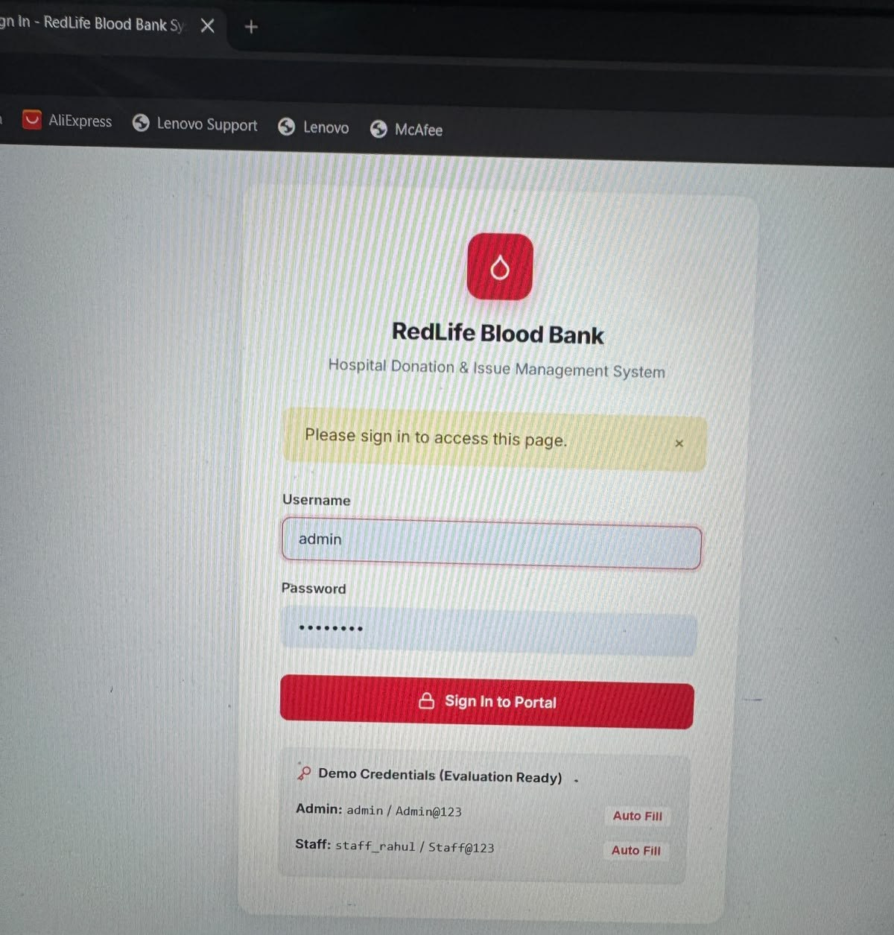
Figure 2. Login Screen with Role-Based Access
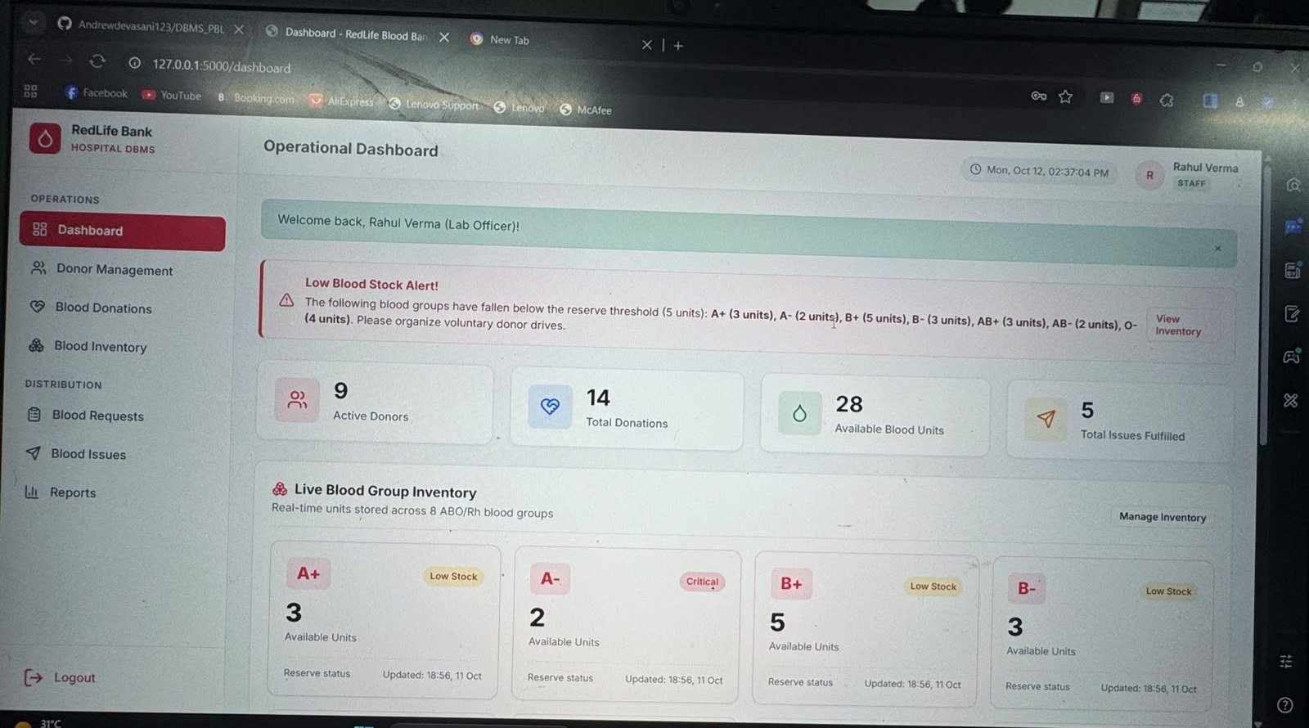
Figure 3. Dashboard with Live KPI Cards, Inventory Grid and Low-Stock Alert
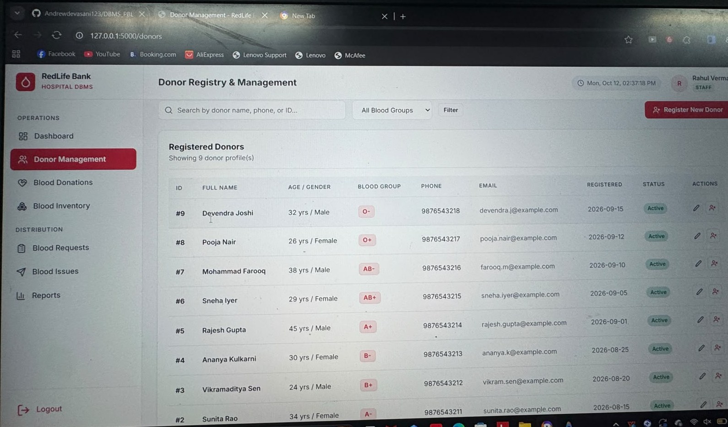
Figure 4. Donor Registration and Search
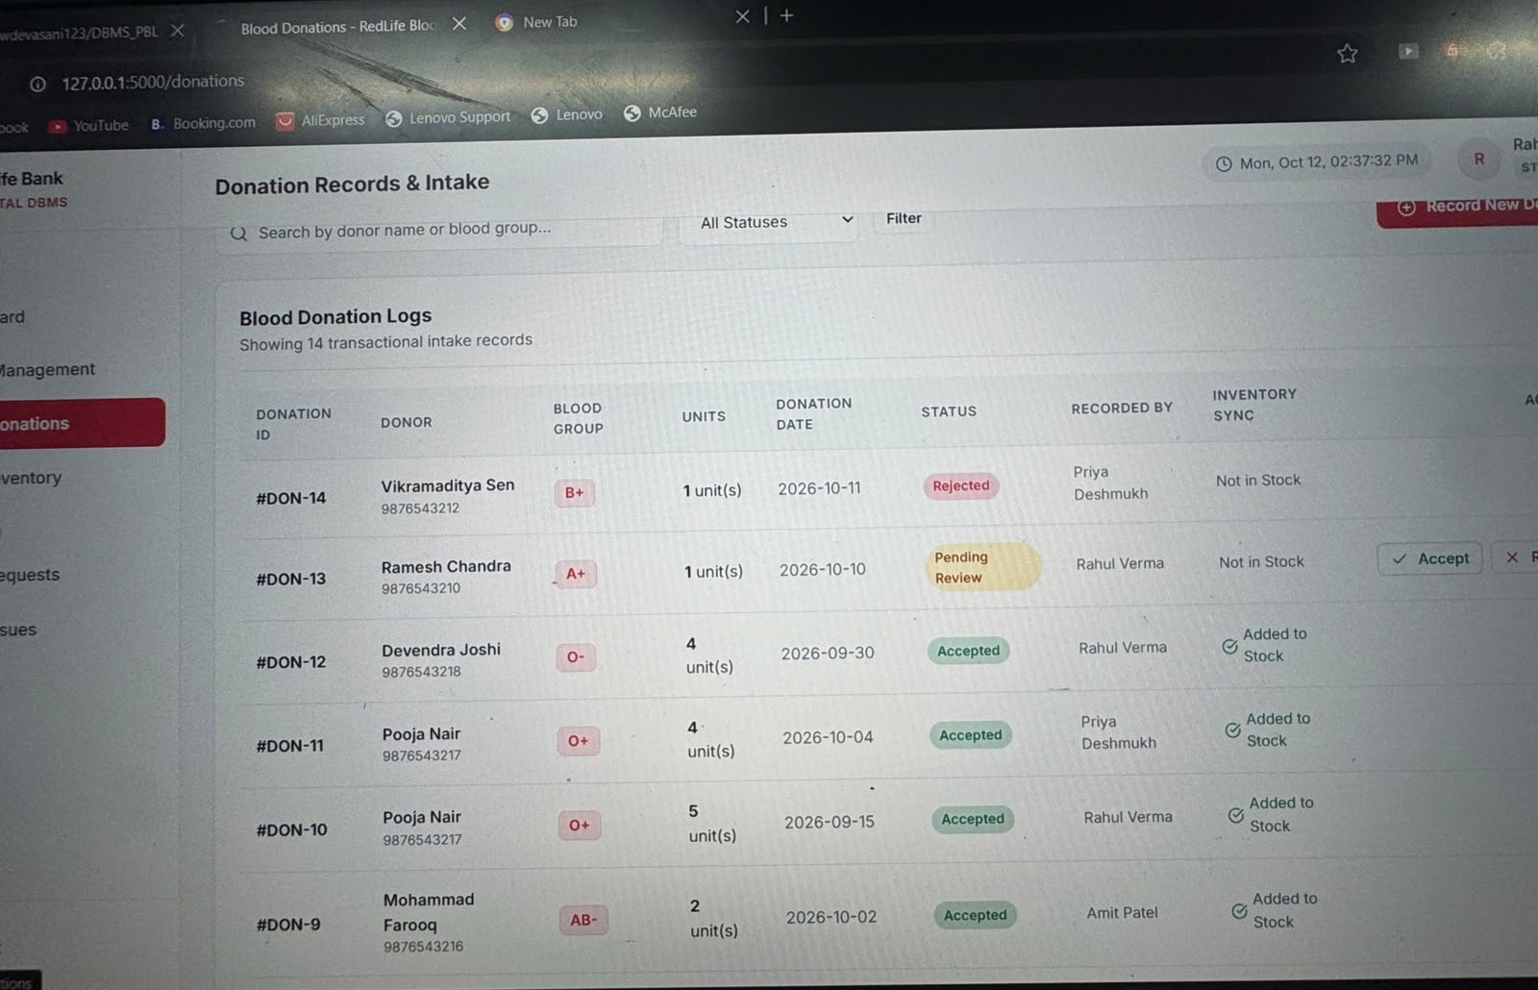
(a) Donation log showing Accepted, Pending and Rejected records
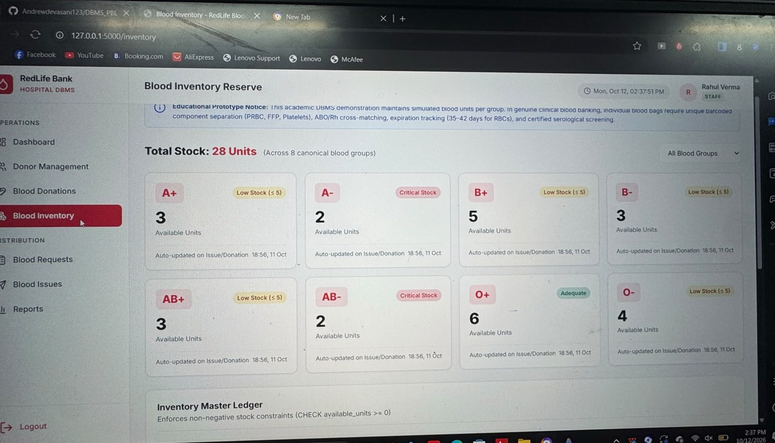
(b) Inventory after acceptance: live stock per blood group
Figure 5. Donation Recording and Inventory Increment
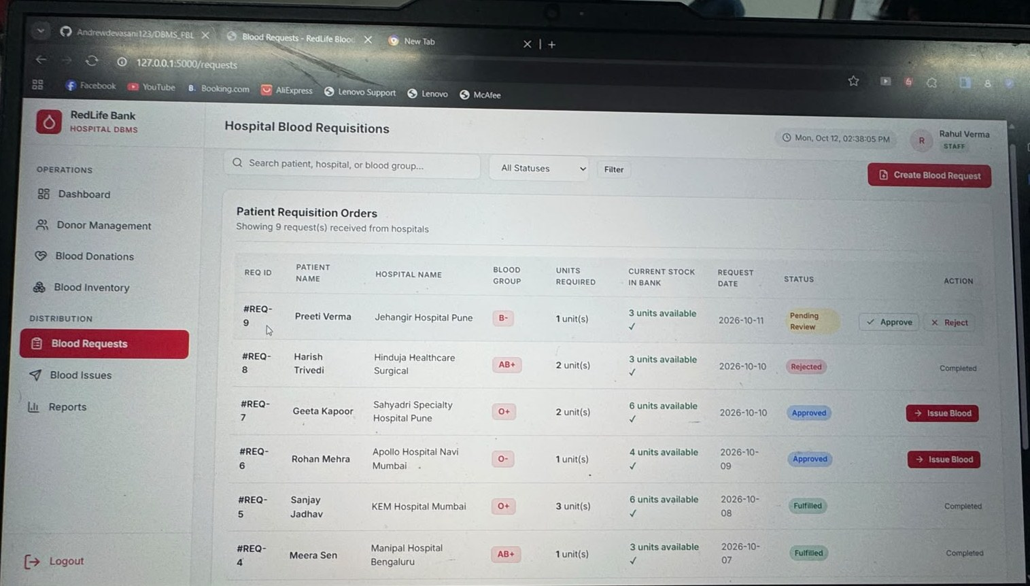
(a) Hospital requisitions with stock comparison and Approve / Issue actions
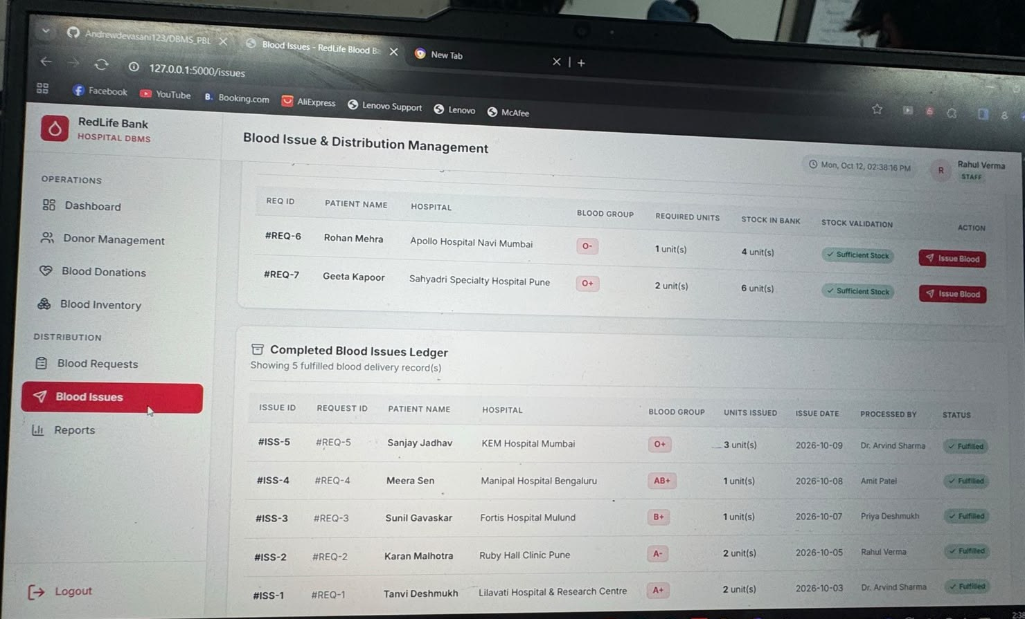
(b) Issue screen and ledger of fulfilled blood issues
Figure 6. Blood Request Approval and Atomic Blood Issue
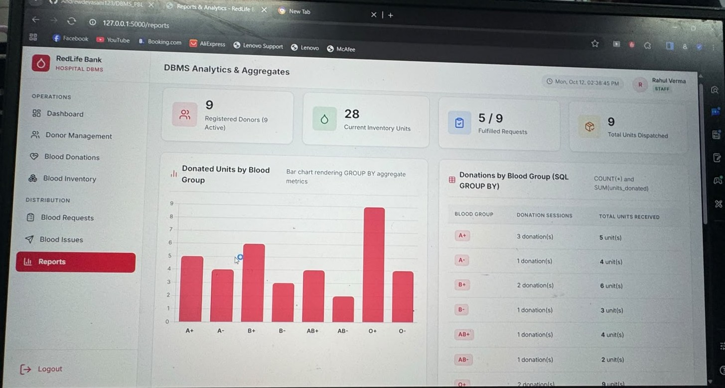
Figure 7. Reports Page with Donation Distribution Chart

3.8 Testing and Results
The automated suite in tests/test_system.py exercises the real Flask application against the MySQL database. Table 15 lists the test cases; they cover 12 evaluation criteria in 11 pytest functions, because the issue and stock-decrease checks (TC-08 and TC-09) are verified together in one function. Positive cases confirm that correct input produces the right database changes, and negative cases (TC-03, TC-10, TC-11, TC-12) confirm that invalid actions are refused without changing the data.
Table 15. Test Cases
Test ID | Feature | Input / Action | Expected Result | Actual Result | Status
TC-01 | Admin login | admin with its password | Session created with role admin | Session holds role admin and username admin | Passed
TC-02 | Staff login | staff_rahul with its password | Session created with role staff | Session holds role staff and username staff_rahul | Passed
TC-03 | Access control | /dashboard and /donors without login; staff opens /users | Redirect to login; staff redirected to dashboard | Redirects returned as expected | Passed
TC-04 | Donor registration | New A+ donor, age 29 | Donor row inserted | Row found with correct name, group and age | Passed
TC-05 | Pending donation | Donation of 1 unit with status Pending | Saved as Pending; stock not changed | status Pending, inventory_updated 0 | Passed
TC-06 | Stock increase | Accepted donation of 2 units, O+ donor | O+ stock rises by 2 | Stock after = stock before + 2 | Passed
TC-07 | Request creation | New request for 1 unit | Request saved as Pending | Row found with status Pending, 1 unit | Passed
TC-08 | Blood issue | Issue an Approved request | Request Fulfilled; issue row created | Status Fulfilled; 1 unit issued | Passed
TC-09 | Stock decrease | Same action as TC-08 | Stock reduced by units issued | Stock after = stock before - 1 | Passed
TC-10 | Insufficient stock (negative) | Issue an Approved request for 500 units of AB- | Error message; inventory unchanged | "Insufficient stock" shown; stock unchanged | Passed
TC-11 | Duplicate issue (negative) | Issue an already Fulfilled request again | Second issue refused | Refusal message shown | Passed
TC-12 | Invalid inputs (negative) | Donor age 14, age 78, blood group Z_POSITIVE | Each form rejected with message | Age message shown twice; invalid-field message shown | Passed

The recorded run of the suite reports 11 passed tests in 18.68 seconds. These results show that the application reads and writes the designed tables, that stock moves only through accepted donations and issues, and that the key business rules are enforced: age limits, positive units, role-based access, no issue without sufficient stock, and no duplicate issue of a request.

CHAPTER 4

CONCLUSION

This project addressed the problem of keeping blood donation, stock and hospital requests consistent in a blood bank. An ER model with six entities was converted into six MySQL tables with primary keys, foreign keys, UNIQUE, CHECK and DEFAULT constraints, normalized to Third Normal Form with one documented, deliberate exception, and loaded with consistent sample data. A Flask application was built on this design with role-based login, donor and donation management, live inventory, requests, atomic blood issue, and dashboard and report pages driven by aggregate SQL.
The work showed in practice how constraints and transactions protect data that matters: row-level locking and rollback stop stock from going negative or being issued twice, and parameterised queries and server-side validation keep bad input out of the database. Eleven automated tests confirm these behaviours. The main learning outcome was seeing how a clean logical design makes the application simpler, because most rules can be enforced once in the database instead of being repeated everywhere in code.

4.1 Limitations and Future Enhancements
- Stock is kept as one counter per blood group. Future work could track individual bags with collection and expiry dates and issue the oldest unit first.
- Donor eligibility is limited to the age range. A minimum interval between donations and health screening results could be added as further rules.
- Consistency between inventory and the donation and issue tables is maintained by application transactions. Database triggers or stored procedures could enforce it even for direct SQL changes.
- Requests cannot be edited after creation, and the application runs on the Flask development server. Request editing, audit logs, CSV or PDF export, notifications and deployment behind a production server with HTTPS are realistic next steps.

REFERENCES

[1] A. Silberschatz, H. F. Korth, and S. Sudarshan, Database System Concepts, 7th ed. New York, NY, USA: McGraw-Hill, 2020.
[2] Pallets, Flask Documentation, ver. 3.1. Accessed: Oct. 12, 2026. [Online]. Available: https://flask.palletsprojects.com/
[3] Oracle Corporation, MySQL 8.0 Reference Manual. Accessed: Oct. 12, 2026. [Online]. Available: https://dev.mysql.com/doc/refman/8.0/en/
[4] P. P.-S. Chen, “The entity-relationship model—toward a unified view of data,” ACM Trans. Database Syst., vol. 1, no. 1, pp. 9–36, Mar. 1976, doi: 10.1145/320434.320440.
[5] E. F. Codd, “A relational model of data for large shared data banks,” Commun. ACM, vol. 13, no. 6, pp. 377–387, Jun. 1970, doi: 10.1145/362384.362685.
[6] Oracle Corporation, MySQL Connector/Python Developer Guide. Accessed: Oct. 12, 2026. [Online]. Available: https://dev.mysql.com/doc/connector-python/en/
[7] Pallets, Werkzeug Documentation, ver. 3.1. Accessed: Oct. 12, 2026. [Online]. Available: https://werkzeug.palletsprojects.com/

APPENDICES

APPENDIX A - COMPLETE DATABASE SCRIPT
The complete database script is submitted as three files in the repository folder blood_bank_project: schema.sql (database, six tables and five indexes), sample_data.sql (consistent demo records) and dbms_queries.sql (DDL, DML, ten SELECT queries and a transaction demonstration). The full text of schema.sql is reproduced below.
-- =======================================================================
-- BLOOD BANK DONATION AND ISSUE MANAGEMENT SYSTEM
-- Database Schema Definition (schema.sql)
-- Target RDBMS: MySQL 8.0+
-- Design Standard: Third Normal Form (3NF)
-- =======================================================================

CREATE DATABASE IF NOT EXISTS blood_bank_db
CHARACTER SET utf8mb4
COLLATE utf8mb4_unicode_ci;

USE blood_bank_db;

-- -----------------------------------------------------------------------
-- 1. Table: users
-- Purpose: System authentication and role-based access (Admin, Staff)
-- -----------------------------------------------------------------------
DROP TABLE IF EXISTS blood_issues;
DROP TABLE IF EXISTS blood_requests;
DROP TABLE IF EXISTS donations;
DROP TABLE IF EXISTS inventory;
DROP TABLE IF EXISTS donors;
DROP TABLE IF EXISTS users;

CREATE TABLE users (
user_id INT AUTO_INCREMENT PRIMARY KEY,
username VARCHAR(50) NOT NULL UNIQUE,
password_hash VARCHAR(255) NOT NULL,
full_name VARCHAR(100) NOT NULL,
email VARCHAR(100) NOT NULL UNIQUE,
role ENUM('admin', 'staff') NOT NULL DEFAULT 'staff',
is_active BOOLEAN NOT NULL DEFAULT TRUE,
created_at TIMESTAMP DEFAULT CURRENT_TIMESTAMP
) ENGINE=InnoDB;

-- -----------------------------------------------------------------------
-- 2. Table: donors
-- Purpose: Registry of prospective and active blood donors
-- -----------------------------------------------------------------------
CREATE TABLE donors (
donor_id INT AUTO_INCREMENT PRIMARY KEY,
full_name VARCHAR(100) NOT NULL,
age INT NOT NULL,
gender ENUM('Male', 'Female', 'Other') NOT NULL,
blood_group ENUM('A+', 'A-', 'B+', 'B-', 'AB+', 'AB-', 'O+', 'O-') NOT NULL,
phone VARCHAR(20) NOT NULL,
email VARCHAR(100) NULL,
address VARCHAR(255) NULL,
is_active BOOLEAN NOT NULL DEFAULT TRUE,
registration_date DATE NOT NULL DEFAULT (CURRENT_DATE),
created_at TIMESTAMP DEFAULT CURRENT_TIMESTAMP,
CONSTRAINT chk_donor_age CHECK (age >= 18 AND age <= 65)
) ENGINE=InnoDB;

-- -----------------------------------------------------------------------
-- 3. Table: inventory
-- Purpose: Real-time available units per blood group (Educational prototype)
-- Maintains exactly 8 canonical rows, one for each blood group.
-- -----------------------------------------------------------------------
CREATE TABLE inventory (
blood_group ENUM('A+', 'A-', 'B+', 'B-', 'AB+', 'AB-', 'O+', 'O-') PRIMARY KEY,
available_units INT NOT NULL DEFAULT 0,
last_updated TIMESTAMP DEFAULT CURRENT_TIMESTAMP ON UPDATE CURRENT_TIMESTAMP,
CONSTRAINT chk_inventory_non_negative CHECK (available_units >= 0)
) ENGINE=InnoDB;

-- -----------------------------------------------------------------------
-- 4. Table: donations
-- Purpose: Transactional log of blood donations provided by registered donors
-- -----------------------------------------------------------------------
CREATE TABLE donations (
donation_id INT AUTO_INCREMENT PRIMARY KEY,
donor_id INT NOT NULL,
blood_group ENUM('A+', 'A-', 'B+', 'B-', 'AB+', 'AB-', 'O+', 'O-') NOT NULL,
donation_date DATE NOT NULL DEFAULT (CURRENT_DATE),
units_donated INT NOT NULL DEFAULT 1,
status ENUM('Pending', 'Accepted', 'Rejected') NOT NULL DEFAULT 'Pending',
recorded_by INT NOT NULL,
inventory_updated BOOLEAN NOT NULL DEFAULT FALSE,
remarks VARCHAR(255) NULL,
created_at TIMESTAMP DEFAULT CURRENT_TIMESTAMP,
CONSTRAINT chk_donation_units CHECK (units_donated > 0),
CONSTRAINT fk_donations_donor FOREIGN KEY (donor_id)
REFERENCES donors(donor_id)
ON UPDATE CASCADE
ON DELETE RESTRICT,
CONSTRAINT fk_donations_user FOREIGN KEY (recorded_by)
REFERENCES users(user_id)
ON UPDATE CASCADE
ON DELETE RESTRICT
) ENGINE=InnoDB;

-- -----------------------------------------------------------------------
-- 5. Table: blood_requests
-- Purpose: Requests submitted by hospitals/patients for blood units
-- -----------------------------------------------------------------------
CREATE TABLE blood_requests (
request_id INT AUTO_INCREMENT PRIMARY KEY,
patient_name VARCHAR(100) NOT NULL,
hospital_name VARCHAR(150) NOT NULL,
blood_group ENUM('A+', 'A-', 'B+', 'B-', 'AB+', 'AB-', 'O+', 'O-') NOT NULL,
units_required INT NOT NULL,
request_date DATE NOT NULL DEFAULT (CURRENT_DATE),
status ENUM('Pending', 'Approved', 'Rejected', 'Fulfilled') NOT NULL DEFAULT 'Pending',
created_by INT NOT NULL,
created_at TIMESTAMP DEFAULT CURRENT_TIMESTAMP,
CONSTRAINT chk_request_units CHECK (units_required > 0),
CONSTRAINT fk_requests_user FOREIGN KEY (created_by)
REFERENCES users(user_id)
ON UPDATE CASCADE
ON DELETE RESTRICT
) ENGINE=InnoDB;

-- -----------------------------------------------------------------------
-- 6. Table: blood_issues
-- Purpose: Record of blood units formally issued against approved requests
-- Note: UNIQUE(request_id) guarantees that one request cannot be fulfilled multiple times.
-- -----------------------------------------------------------------------
CREATE TABLE blood_issues (
issue_id INT AUTO_INCREMENT PRIMARY KEY,
request_id INT NOT NULL UNIQUE,
patient_name VARCHAR(100) NOT NULL,
blood_group ENUM('A+', 'A-', 'B+', 'B-', 'AB+', 'AB-', 'O+', 'O-') NOT NULL,
units_issued INT NOT NULL,
issue_date DATE NOT NULL DEFAULT (CURRENT_DATE),
issued_by INT NOT NULL,
created_at TIMESTAMP DEFAULT CURRENT_TIMESTAMP,
CONSTRAINT chk_issue_units CHECK (units_issued > 0),
CONSTRAINT fk_issues_request FOREIGN KEY (request_id)
REFERENCES blood_requests(request_id)
ON UPDATE CASCADE
ON DELETE RESTRICT,
CONSTRAINT fk_issues_user FOREIGN KEY (issued_by)
REFERENCES users(user_id)
ON UPDATE CASCADE
ON DELETE RESTRICT
) ENGINE=InnoDB;

-- -----------------------------------------------------------------------
-- INDEXES FOR COMMONLY SEARCHED AND FILTERED FIELDS
-- -----------------------------------------------------------------------
CREATE INDEX idx_donors_search ON donors (full_name, blood_group, is_active);
CREATE INDEX idx_donations_status ON donations (status, blood_group);
CREATE INDEX idx_donations_donor ON donations (donor_id);
CREATE INDEX idx_requests_status ON blood_requests (status, blood_group);
CREATE INDEX idx_issues_date ON blood_issues (issue_date);

APPENDIX B - APPLICATION SOURCE CODE
The complete source code is available in the GitHub repository https://github.com/Andrewdevasani123/DBMS_PBL.git (folder blood_bank_project). The main files are app.py (routes and business logic), db.py (connection and query helpers), the Jinja2 templates in templates/, static/css/style.css and static/js/main.js, and the pytest suite in tests/test_system.py. Setup instructions are in README.md.

APPENDIX C - ADDITIONAL TEST DATA AND OUTPUTS
The sample data is built so that inventory equals accepted donations minus issued units for every blood group. The reconciliation and the recorded output of the automated test run are given below.
Group Accepted Issued Available
A+ 5 2 3
A- 4 2 2
B+ 6 1 5
B- 3 0 3
AB+ 4 1 3
AB- 2 0 2
O+ 9 3 6
O- 4 0 4
Total 37 9 28
python -m pytest tests/test_system.py -v

test_01_admin_login PASSED
test_02_staff_login PASSED
test_03_unauthorized_access PASSED
test_04_donor_registration PASSED
test_05_donation_recording PASSED
test_06_inventory_increase PASSED
test_07_blood_request_creation PASSED
test_08_and_09_blood_issue_and_inventory_decrease PASSED
test_10_insufficient_inventory PASSED
test_11_duplicate_issue_prevention PASSED
test_12_invalid_form_inputs PASSED
11 passed in 18.68s

